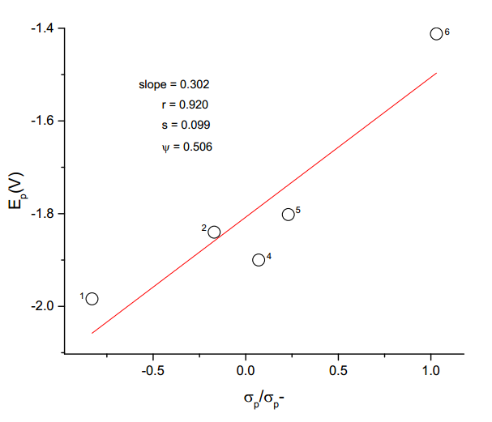

Fig. Hammett plot for the electrolytic reduction of substituted (E)-1-(furan-2-yl)-

3-(4’-phenyl)-prop-2-ene-1-ones.

(second peak; numbering as in Table ). Sweep rate = 320 mV/s.